CS 340

Project Step 3 Draft

24 JUL 2023

**Team members**:

Braeden Newcomer

Nicholai Moguet

GEAD SITE: http://flip2.engr.oregonstate.edu:55340/countries

Feedback on Step 3 Draft

* "Only countries, energy types, consumers, and providers have the actual required forms for entering in the attribute information."
* "Make sure to add delete buttons to each of you tables, as well as cross checking for intersection table attributes to be deleted on cascade when a foreign key is deleted."
* "I would recommend making consumers to energy provisions as an optional relationship [in the ERD]"
* "I would group my entities together in the modification sql so it would be easier to read. Like all the provider ones together."
* "Users can interact with inputs corresponding to each table's attributes, allowing them to add new data on the website on some pages, but not all."
* "A lot of the edit buttons aren’t connected to an edit page."

Actions in Response to Feedback

We have implemented input forms as well as delete and edit buttons for every entity. We also indicated that the optional nature of the relationship between Providers and the Energy_Provisions Table in the ERD and Schema, and grouped queries by entity in the modification SQL. Additionally, we edited the Schema to include optional participation symbols which indicate the following: Countries can exist without any Consumers or Providers, and Energy_Types can exist without having any Providers or Consumers. Each of these scenarios seems plausible.

Project proposal for a Global Energy Accessibility Database

The Global Energy Accessibility Database (GEAD) aims to address the issue of information fragmentation and lack of comprehensive data regarding energy usage and accessibility across the globe. Currently, data on energy types, providers, and consumers, particularly at the city or town level, are scattered across various sources making it difficult for policymakers, researchers, and energy companies to get a holistic view of energy distribution and provision. By consolidating this information into a single, structured database, GEAD can provide insights into energy consumption patterns and availability of different energy types. This could help in identifying energy accessibility gaps, planning for infrastructure development, creating effective energy policies, and strategizing for more equitable energy distribution, ultimately contributing to the global efforts towards sustainable and accessible energy for all. GEAD would track the *Energy_Types* distributed by 350 *Providers* to over 14,000 municipal *Consumers* spanning more than 100 *Countries* worldwide.

Here is an outline of the database:

**Countries**: Records details about different countries around the world.

* *countryID*: int, auto_increment, unique, not NULL, PK. This is the unique identifier for each country.
* *countryName*: varchar, unique not NULL. The official name of the country.
* *globalRegion*: varchar, not NULL. The geographical region in which the country is located.
* *population*: bigint. The total population of the country.
* *GDP*: decimal, not NULL. The Gross Domestic Product of the country in USD.
* Relationships: A 1:M relationship with Consumers, and a M:N relationship with Providers entities through the National_Operations intersection table. A country can have multiple Consumers and multiple Providers.

**Energy_Types**: Stores data about different forms of energy being used (solar, wind, coal, nuclear, etc.).

* *energyTypeID*: int, auto_increment, unique, not NULL, PK. A unique identifier for each type of energy.
* *energyName*: varchar, not NULL. The name of the type of energy.
* *description*: text, not NULL. A brief description of the energy type.
* *emissionsRate:* int. Tonnes of CO2 - equivalent emissions per gigawatt-hour at average power plant.
* *deathRate*: decimal. Death rate from accidents and pollution per terawatt-hour of production.
* Relationships: M:N relationship with Providers through the Provider_Energy_Types table, which represents the types of energy a specific provider produces and is *capable* of providing. Ternary M:N relationship with Consumers and Providers through the Energy_Provisions table, which represents the *ongoing* provision of a specific Energy_Type by a specific Provider to a specific Consumer. The up-to-date database will track current provisions of energy, as opposed to past transactions.

**Consumers**: Records data about energy consumers, represented as local municipalities.

* *consumerID*: int, auto_increment, unique, not NULL, PK. A unique identifier for each municipality.
* *municipality*: varchar, not NULL. The name of the municipality.
* *population*: int, not NULL. The population of the municipality.
* *countryID*: int, not NULL, FK. The identifier for the country in which the municipality is located.
* Relationships: A ternary M:N relationship with Providers and Energy_Types through the Energy_Provisions intersection table. An additional M:1 relationship with Countries: a Country may have many Consumers, but each Consumer has one Country.

**Providers**: Contains information about energy providers.

* *providerID*: int, auto_increment, unique, not NULL, PK. A unique identifier for each provider.
* *providerName*: varchar, not NULL. The name of the provider.
* *orgType*: varchar, not NULL. The type of the provider (public, private, cooperative, etc.).
* Relationships: A ternary M:N relationship with the Consumers and Energy_Types entities through the Energy_Provisions intersection table, and a M:N relationship with the Energy_Types through the Provider_Energy_Types table.

**Provider_Energy_Type** (intersection table): Records a type of energy produced by the provider. Distinct from the Energy_Provisions table in that a Provider may produce some energy types of which the database has no Energy_Provisions record.

* *providerID*: int, not NULL, FK. The identifier for the Provider providing energy type.
* *energyTypeID*: int, not NULL, FK. The identifier for the energy type.
* Relationships: Implements the M:N relationship between Providers and Energy_Types, as a provider can have multiple energy types, and each energy type has multiple providers.

**Energy_Provisions (Intersection Table)**: Records the ongoing provision of Energy_Types from Providers to Consumers.

* *providerID*: int, not NULL, FK. The identifier for the Provider supplying the energy.
* *consumerID*: int, not NULL, FK. The identifier for the municipality consuming the energy.
* *energyTypeID*: int, not NULL, FK. The identifier for the Energy_Type provided.
* Relationships: Serves to implement the ternary M:N relationship between the Providers, Energy_Types, and Consumers entities. This allows for tracking which Providers supply which Energy_Types to which Consumers.

**National_Operations (Intersection Table)**: Records the present operation of specific Providers in specific Countries.

* *providerID*: int, not NULL, FK. The identifier for the operating Provider.
* *countryID*: int, not NULL, FK. The identifier for the Country of operation.
* Relationships: Serves to implement the M:N relationship between Providers and Countries entities. It allows tracking which Providers operate in which Countries.

Specific Feedback and Our Responses

* We received mutiple comments about our ERD not matching the schema. We've carefully reviewed both to ensure consistency.
* We also received multiple comments about the possible confusion caused by the inclusion of three intersection tables: Consumed_Energies between Consumers and Energy_Types, Provided_Energies between Providers and Energy_Types, and Provider_Energy_Types between Providers and Energy_Types. To this end, we've condensed the Provided_Energies and Consumed_Energies into a single intersection table Energy_Provisions, which implemenets a ternary M:N relationship between Providers, Consumers, and Energy_Types. Each row will be a single provision of a specific Energy_Type by a specific Provider to a specific Consumer. Additionally, we used the name Energy_Provisions to distinguish the table from Provider_Energy_Types, which tracks the Energy_Types produced by specific Providers, but not necessarily recorded by an Energy_Provisions entry. This way, we may know that a provider produces energies x, y, and z without knowing to whom these energies are provided.
* Some classmates noted that the attribute "totalProviders" was plural and could be easily calculated in real time, so we've removed that attribute.
* Someone pointed out that "exchangeRate" would be constantly fluctuating. We actually cut the use of monetary records completely (other than GDP). These attributes made the database unnecessarily complex and distracted from the purpose of tracking availability and provision of energy types. Thus, the Currencies intersection table is completely gone.

ERD

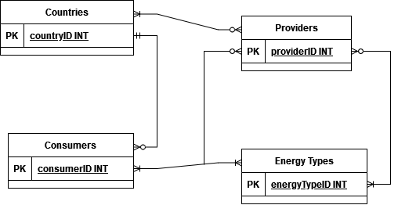

Schema

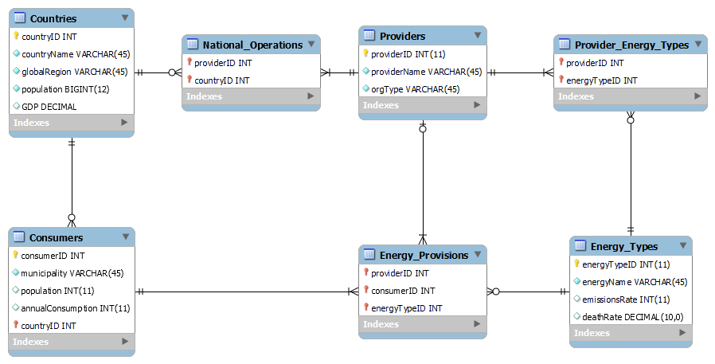

Sample Data (Taken from our site)

**Countries**

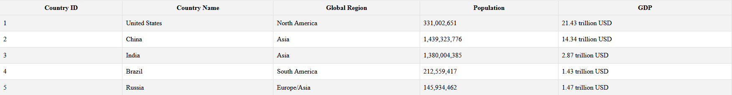

**Energy_Types**

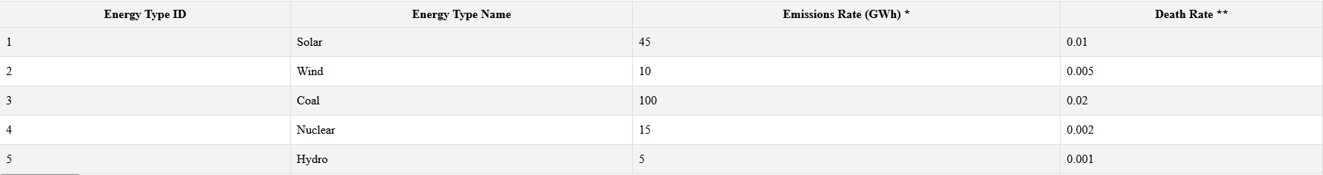

**Consumers**

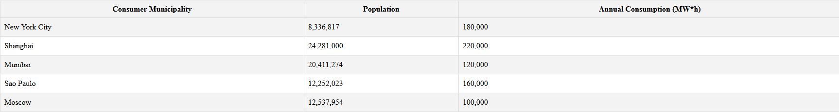

**Providers**

